Community Sustainability
Report 2017
Table of Contents

Kingston – Leading The Way to A Sustainable Future 3
Chapter 1 – Climate Action 4
Did You Know? 4
Friendly Welcome To Kingston For Tesla Powerwall 5
AMPed Up For Events 5
Waste Not, Want Not 6
Building A Green Economy 7
Walking the Talk – The City of Kingston’s Corporate Climate Action Plan 8
Chapter 2 – Economic Prosperity 9
Did You Know? 9
The Mayor’s Innovation Tour 10
Beginning Again 10
Youth Start-Ups 11
Disabilities Mentoring Day 12
Innovate Kingston Is ‘Breaking Out’ 13
Chapter 3 – Food Security 14
Did You Know? 14
Loving Spoonful's GROW Project 15
Ethical Consumption Made Easy 15
From Farm To Fork - Ethical And Sustainable Food In Kingston 16
Chapter 4 – Sustainable Transportation 19
Did You Know? 19
Kingston Transit ‘APP’tly Getting More People On Board 20
Ridesharing Made Easy 20
Commuter Challenge 21
Dropbike: The Orange Revolution 22
K&P Trail 23
Electric Vehicle Charging Stations 23
Chapter 5 – Sense of Community 25
Did You Know? 25
Broadmind: Strategies For Mental Health 26
Nightlight 26
Community Inclusion Program 27
Katarokwi Learning Centre 28
Co-Working Together 28
Chapter 6 – Environmental Stewardship 30
Did You Know? 30
The Buzz On Campus 31
Trash TurnAround 31
Tracking the Turtles of Inner Harbour 32
Shop Responsibly – Live Sustainably 33
The Water of Cataraqui Region 34
Kingston Pitched-In, Again! 34
Acknowledgements 35
About Sustainable Kingston 36
2016 - 2020 Priorities 36
Share Your Organization's Story 36
Contact us: 36

Kingston – Leading The Way to A Sustainable Future

Kingston is quickly becoming a national leader in the fight against climate change. There are many inspiring and disruptive leaders in the community who are operating on the cutting edge of sustainability theory and practice. The main purpose of this Community Sustainability Report is to tell those stories of community action and thus to celebrate the diverse local responses to the most pressing existential problem facing humanity today.
The four-pillar approach to sustainability recognizes that the intersection of environment, economy, society, and culture is where true sustainability is to be found. In other words, the solution to the root causes of climate change is to take action to conserve eco-system wellbeing, contribute to regenerative and prosperous local economies, commit to caring and empathetic communities, and celebrate our society’s diverse and vibrant cultural life.
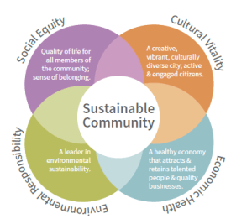
This report is structured around Sustainable Kingston’s six priority areas, which are themselves the application of our four-pillar approach to sustainability. The six priority areas are Sustainable Kingston’s method of identifying actionable, target-based elements of sustainability so that we can measure our impact and therefore the success, or failure, of our efforts. As you will see by even a quick glance through this report, the Kingston community is engaged and innovative in all aspects of sustainability. While there is still more to do, together, we are already making a clear difference. Indeed, the stories here are just the highlights of the many reasons to be inspired and optimistic as we look ahead to the future.

Chapter 1 – Climate Action

Climate change is today’s most significant global threat to our quality of life. This generation’s response to climate change will be our most important legacy. As a community, we have a responsibility to take action. This section features some of local businesses, organizations, and institutions that are working to shrink Kingston’s carbon footprint and reduce our vulnerability to the changing climate.

Did You Know?

DYK? Methane is 25 times more potent than carbon dioxide in terms of its global warming potential. 20% of all methane emissions in Canada come from landfills.
Source: Government of Canada
DYK? In Ontario, 6% of our energy comes from wind, less than 1% from solar and less than 1% from bioenergy and none of our energy comes from coal.
Source: Ministry of Energy
DYK? Climate change for Kingston means warmer, wetter, and more extreme weather.
Source: Kingston Climate Action Plan

Friendly Welcome To Kingston For Tesla Powerwall
Tesla is known for its sleek, in-demand electric vehicles and for its innovative technology and even more innovative marketing techniques. The Tesla Powerwall is no exception. It is an electrical storage solution that allows users to back up their power supply by charging a compact battery, either through the grid or through solar panels. It has the unique feature of being able to charge and discharge power simultaneously. And it is now available in Kingston.
Friendly Fires is Eastern Ontario’s exclusive distributor of this recent, high-profile technology. Curtis Andre of Friendly Fires explains that the Tesla Powerwall is a natural extension of what they do, which includes supplying sustainable products for heating and electricity. So, where does Tesla’s newest product fit in? Ontario is currently transitioning to net metering, meaning that those producing power will be credited on their bill for their electricity production and will be charged for electricity that they consume from the grid. Net metering allows home or business owners to use electricity from the Powerwall during the more expensive time-of-use periods, a tactic called “peak shaving.” Friendly Fires doesn’t anticipate a huge uptake of Tesla Powerwall adopters at first, given that it is an expensive technology, although they have already sold four. Welcoming those early adopters and those looking for alternative backup power, Friendly Fires is happy to take it slow and to enjoy the ride.
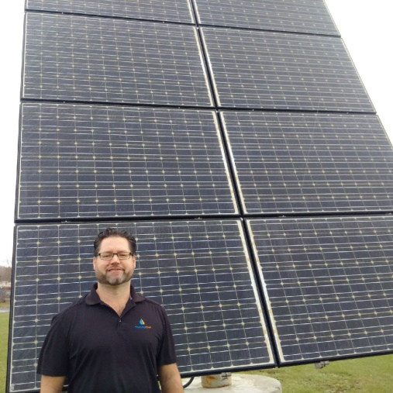

AMPed Up For Events
St. Lawrence College offers a portable off grid power station, powered 100% by solar panels. Boasting energy supply up to 4,000 watts and 10,000 amp hours, the solar trailer is free to use by any community member for events and is great for festivals and music concerts that need sound system plug ins. The solar trailer was used at several events this year including the ARCfest, Sheepdog Trials, a Victoria Day celebration, a film shoot, a skatepark opening and an art festival. Instead of the use of a generator, St. Lawrence College used the solar trailer to power tools used when building its new solar site with 9 arrays of collectors. Each time the solar trailer is used, it provides a carbon-neutral, local source of electricity and promotes awareness about sustainable energy. Although it is hard to know precisely how much grid electricity was saved by using the solar trailer, St. Lawrence College staff, Brooke Gilmour and Mark Ellis-Smith, say that a new tracking system will allow this information to be known next year.
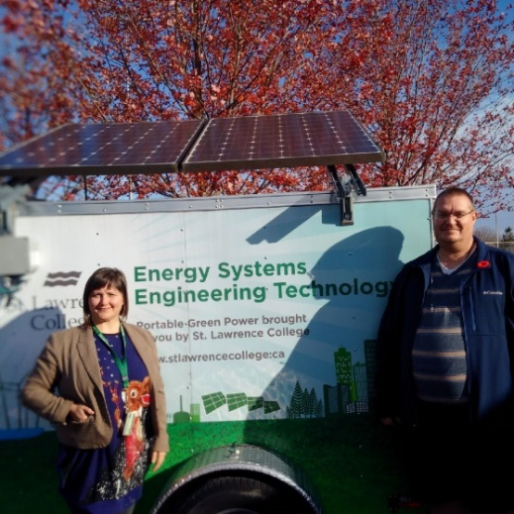

Waste Not, Want Not
Introduced in 2009, the Green Bin program has come a long way in getting people to divert their food waste from landfills. Approximately half of Kingstonians are participating in the program, making green bins an important part of the City’s solid waste management program that provides services to Kingston residents and to downtown businesses. After setting a goal of 60% waste diversion for the entire waste management system, Heather Roberts, Manager of the City of Kingston Solid Waste Division, confirms that this goal was met in 2016 and will be again in 2017. It is estimated that 3,800 tonnes of waste were diverted from landfills through the Green Bin program in 2017 alone, with over half of that consisting of food waste. That is equivalent to reducing greenhouse gas emissions by approximately 62,440 tanks of gasoline! Heather Roberts emphasises that there is still work to be done, as 28% of Kingston’s “garbage” is still food waste. Heather is hoping that more people are aware of the need to divert waste from landfills and notes that the Province has been taking steps towards banning organic waste from landfills entirely in the next few years. With a new bylaw requiring that food waste be included in green bins, Heather is optimistic that people will increasingly love using their green bins for food waste, like they do for yard waste, even if it is one banana peel at a time.
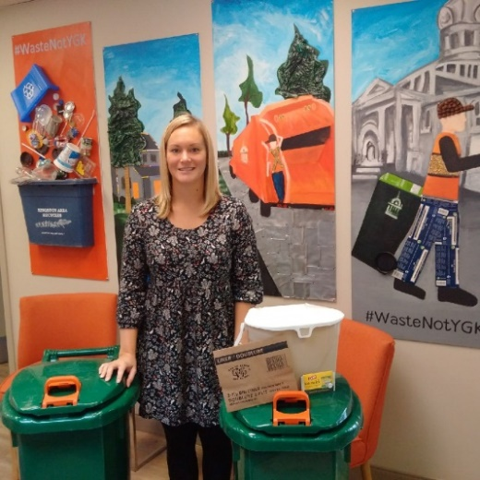

Building A Green Economy
Sustainable Kingston’s Green Economy program began in March of 2016 and has grown rapidly, with 24 member businesses and organizations taking part. Each member is committed to climate action and is supported in measuring their baseline carbon footprint, which is essentially a calculation of the amount of greenhouse gas (GHG) emissions produced by activities such as electricity, natural gas, and water consumption. The program then supports members to take action to reduce emissions, by sharing knowledge and resources, and by helping to prioritize project ideas based on member interest, impact potential, and cost-benefit considerations. The first annual Evening of Recognition celebrated member successes, with Homestead Land Holdings and Kingston Frontenac Housing Corporation both awarded for their efforts. Homestead Land Holdings reduced their GHG emissions by over 400 tonnes by upgrading lighting, installing programmable thermostats, upgrading furnaces and going paperless in their office, which resulted in the largest absolute reduction of GHG emissions among Green Economy members. Kingston & Frontenac Housing Corporation managed to reduce their GHG emissions by 16.5% through a program to replace lighting with LEDs, introducing programmable thermostats, installing low volume showerheads and reducing paper usage by using a company-wide online system. Kingston & Frontenac Housing Corporation noted that the Green Economy program supported them in establishing their mission and putting together a Green Team, which has allowed them to include emissions in their annual report and is a great way to monitor their success.
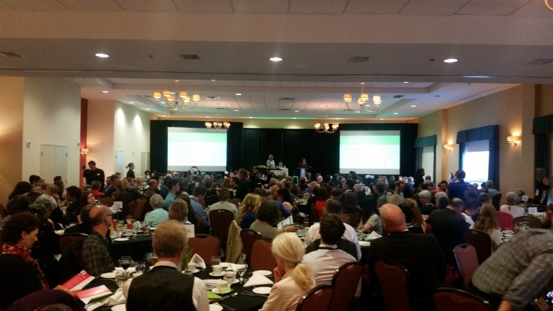

Walking the Talk – The City of Kingston’s Corporate Climate Action Plan
Carbon emissions from municipal operations went down approximately 3% between 2011 and 2015 because of the City of Kingston’s efforts to increase efficiency in its operations. All part of working towards goals set in Kingston’s Climate Action Plan, the City has been working this year on a Corporate Climate Action Plan. The Corporate Climate Action Plan is a strategy for municipal actions that will be even more progressive than past efforts. Previous contributions like retrofitting buildings and street lighting and a more fuel-efficient fleet of cars have all done their part to reducing greenhouse gas emissions. The Corporate Climate Action Plan is furthering efforts to reduce greenhouse gas emissions from the base year 2011.

Chapter 2 – Economic Prosperity

Prosperous cities are cities that are not just productive; they are also inclusive, healthy, safe, resilient, and green. In Kingston, we are building on our strengths by fostering entrepreneurship and innovation. We acknowledge the important role culture and creativity play in wealth creation, and also in making Kingston a vibrant, vital community that retains students and attracts young professionals. We manage our environmental and built heritage and build creative experiences that are the basis of an authentic and successful tourism strategy.

Did You Know?

DYK? Kingston has an unemployment rate of 6.6%. This is 0.2% higher than the Provincial average.
Source: Kingston Economic Development
DYK? The Kingston & Frontenac Housing Corporation, Town Homes Kingston, and Homebase housing are three local not-for-profit organizations that provide accessible housing for those in need in Kingston.
Source: Sustainable Kingston
DYK? Kingston's top three employers are CFB Kingston, Queen's University, and Kingston General Hospital. Together they employ almost 20% of Kingston's total labor force.
Source: Kingston Economic Development

The Mayor’s Innovation Tour
Great leaders dream big and Mayor Bryan Paterson has a bold vision for Kingston’s future. He believes Kingston is perfectly positioned to become a smart, liveable, 21st century city. For the Mayor, the increasingly global economy means that size is no longer the most important indicator of a city’s potential. Instead, cultures of innovation, rich local histories, and smaller, tight-knit communities will lead the way forward. And the Mayor isn’t just sitting in his office watching from a leather armchair!
To demonstrate that Kingston is already well on its way to becoming a globally recognized city, the Mayor launched the first ever Mayor’s Innovation Tour. From August to December, the tour showcased more than 15 ground-breaking local projects. Ranging from the Food Bank Garden at the Frontenac Institution, to an automated E. Coli detection system at Tecta PDS, the tour showed that innovation is about more than just new technology. Two of the tour’s final stops were at Tri-Art Manufacturing and Tara Natural Foods, both members of Sustainable Kingston’s Green Economy program and both truly embodying the four-pillars of sustainability.
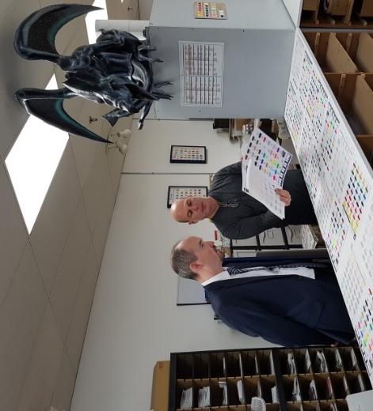

Beginning Again
The Begin Again Group (BAG) initiative supports local refugee women to build community and develop financial independence. With the support of KEYS Job Centre and Bon Echo Design, the BAG collective will develop skills and relations to run a successful business in Canada. A group of eight local refugee women have come together, with their mentor (Bon Eco Design’s owner) to develop a micro enterprise designing and fabricating unique hand-made bags and accessories from recycled rubber tubes.
By participating in the program, these women now have improved language skills and are contributing to their own self purpose and society, instead of being fueled by fear and isolation. They are more informed about their local community and the environment and have gained knowledge and support for running their own successful business.
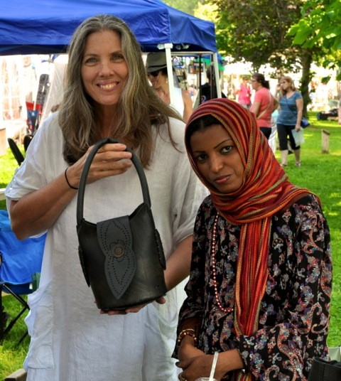

Youth Start-Ups
The Kingston Economic Development Corporation (KEDCO) has been working hard to support Kingston’s growing entrepreneurial community, especially students. With support from the Ontario government’s Summer Company program, KEDCO administered over 30 grants of $3, 000 to student start-ups last summer. The grantees, all between the ages of 15-29 years, also received advice and mentorship from local businesses. Notably, each of these businesses has continued to run through the school year.
In partnership with the City of Kingston and the Frontenac Community Futures Development Corporation, KEDCO was also able to provide 74 grants of $5,000 to youth start-ups through the Starter Company Plus program. Together, the two programs have provided more than $400,000 to Kingston’s youth business community over the past 3 years. Some of the businesses these programs have helped succeed include: Mero Technologies, New Sweater Fingerboards, Mercury Media, and Improbable Escapes.
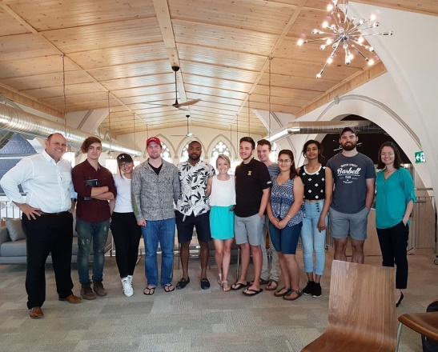

Disabilities Mentoring Day
Each year, Disabilities Mentoring Day (DMD) brings people with disabilities and businesses together to help bridge the employment gaps that exist in our community. Since 2016, KEYS Employment Centre has hosted this one-day opportunity for a job-ready person with disabilities to be paired up with a local business looking for talent. In 2017, KEYS matched 11 mentees with mentors from businesses and agencies including Queen’s University, Sustainable Kingston, the City of Kingston, and Rapid Valley restaurant.
Through DMD, mentees are able to expand their work experience and their professional network. They can also better understand the accommodations they might require for work and skill development. Advantages to the employers include increasing employee confidence and reducing workplace bias. Those with disabilities are generally well education and are therefore an ‘untapped pool of talent.’ They not only increase workplace diversity and innovation, they also give employers a competitive advantage.
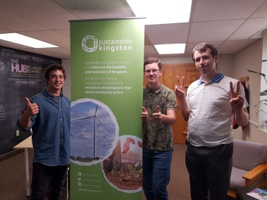

Innovate Kingston Is ‘Breaking Out’
Innovate Kingston is a grass roots not-for-profit focused on building Kingston’s entrepreneurial economy. This spring, they hosted one of Canada’s largest social innovation events at Fort Henry. Over 48 hours, the Breakout Project brought together entrepreneurs, leading speakers, and more the 700 attendees in attempt to develop and fund a world-changing innovation. The Breakout Project raised more than $18,000 for entrepreneurial teams and culminated with the Sam Roberts Band playing for a crowd of over 4000 people.
Outside the Breakout Project, Innovate Kingston continues to support the emergence of $100 million technology related businesses in Kingston. 2017 was the second year of their business accelerator program run out of the Town Hall building in Portsmouth Village. This 5-year pilot program was launched with the support of City Council and has already helped several local start-ups including Wavve Boating, a navigation app for recreational boat owners!

Chapter 3 – Food Security

Most of the food we buy comes from outside of the Kingston region and travels long distances to get here. A strong local food system is important for local economic development, climate resilience, and for providing healthy and sustainable food to our community. Supporting local farmers and ensuring access for all to healthy, nutritious food contributes to a healthy, equitable society and healthy environment.
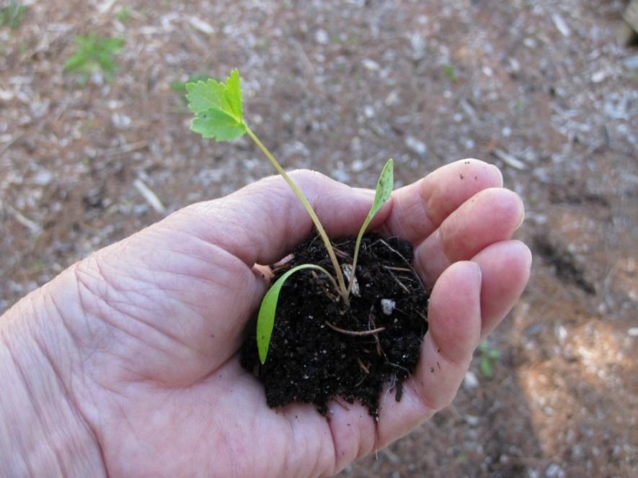

Did You Know?

DYK? The Partner's in Mission FoodBank 6th Annual “Fill an Ambulance” food drive raised $650.25 and secured over 5300 lbs of non-perishable food donations.
Source: Kingston Partners in Mission FoodBank
DYK? The 100% producer-run Memorial Centre Farmers Market is open for 49 weeks a year.
Source: Memorial Centre Farmers Market
DYK? The City of Kingston has a Community Orchard and Edible Forest Policy aimed at promoting community-led planting and maintenance of food-producing tree crops.
Source: City of Kingston

Loving Spoonful's GROW Project
Loving Spoonful works toward a healthy, food-secure community in Kingston, and they do this by facilitating fresh food access, skill development and community engagement. Loving Spoonful's newest undertaking, the GROW Project, is bringing curriculum-connected workshops to primary schools across the Kingston area.
Farmers and instructors bring the support and expertise that teachers need to the classroom and out into the school garden. Connecting kids to healthy food and the joy of gardening and working together, leads not only to greater food security, but to an environmental ethic that will carry through their entire lives. Loving Spoonful plans an ambitious expansion of the GROW Project from 7 to 23 schools by 2020.
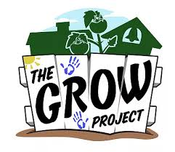

Ethical Consumption Made Easy
With Ethical Tree, you can help ensure you put your money where it counts. Frank Ferris and Siavash Ghazvinian expanded their online ethical directory to our city this October. Ethical Tree is a web-based platform where you can find restaurants, cafés and other businesses in the Kingston area that sell products or services based on social and environmental values. Their current filters include: veg-friendly, fair-trade options, woman-owned businesses, and organic options. However, they hope to expand to include filters for companies that source locally, and uphold environmental standards for recycling, composting and carbon offsets. Partners like the Kingston Vegetarian Network help to ensure that the featured companies uphold certain criteria. The directory also has a crowdsourcing feature where users can flag a business if they notice that it no longer falls under the outlined criteria.
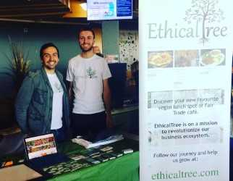

From Farm To Fork - Ethical And Sustainable Food In Kingston
A Community-Supported Agriculture program (CSA) is a farming system in which consumers pay a seasonal membership fee in return for a weekly or bi-weekly share of local farm produce. CSA's are an import part of Kingston's local food economy because they directly connect local farmers and consumers. Farmers receive a reliable operating budget and consumers get a regular supply of local, seasonal produce. A win-win for everyone! Three are highlighted in this report:

CSA 1 – Pasture Makes Perfect
Established in 2010, Fat of the Land is a pasture-based farm in Moscow, Ontario that sells grass-fed and finished beef, field-and-forest pork, and pastured poultry. With a farmer-direct buying club model, farmers Justin and Andrea Hilborn serve the Kingston area and beyond. Customers can order their products and select a pick-up location, or find their meat at locations like the Memorial Centre Farmers Market, Sigrid’s Natural Foods, Bella Bistro and The Grocery Basket.
As opposed to being grain-fed, pasture-raised animals roam freely and eat nutritious grasses and other plants that their bodies are adapted to digest. Not only does that dramatically improve the welfare of farm animals, pasturing also helps reduce environmental damage. At Fat of the Land, the animals graze all year round. For the Hilborn’s, raising responsible, healthy meat starts with their soil. After becoming stewards in Holistic Management, they noticed that their soil was better at retaining water, which led to an increase in plant and wildlife diversity. Healthy soil makes for a healthier planet and of course, better tasting food.
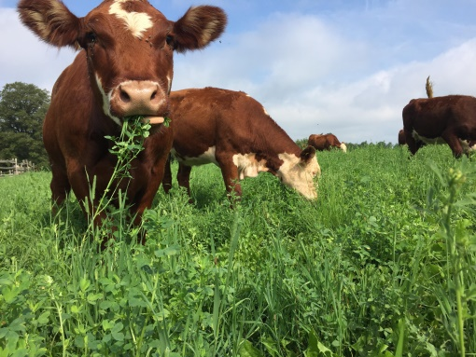

CSA 2 – A Spin On Community Shared Agriculture
Established in 2012, Fat Chance Farmstead offers a unique take on community shared agriculture (CSA). Jen and Josh’s Food Box program runs for 18 weeks and customers take home a box of freshly harvested, seasonal organic food weekly. Unlike typical CSA programs, customers can swap items with one another. This both allows people to get more of what they want, AND it helps to reduce food waste. Customers can pick up the Food Box on Tuesdays at Glenburnie Grocery, or- for those that fall within their district- have it home-delivered. Also, look for their produce at Chez Piggy and Tara Natural Foods.
Want to get your hands in the dirt and learn more about where your food comes? Each summer Fat Chance Farmstead hosts a farm tour. They also send out a weekly newsletter with recipe ideas and stories from the farm. By supporting a small farm, you have the opportunity to get to know and support your local farmers and the food grown within your community. 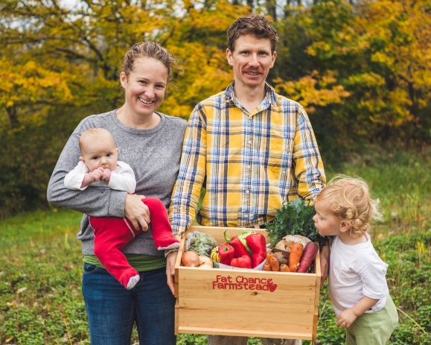

CSA 3 – “Sowing” Community Agriculture
Managing 16 acres and 8 employees, Patchwork Gardens is one of Kingston’s largest Certified Organic vegetable farms. For 14 years, co-owners Megan, Ian, and Eric have been an integral part of Kingston’s growing local food economy. They have combined a small CSA program with wholesale selling to create a profitable and growing local business.
When Sustainable Kingston visited, the team at Patchwork was busy packing potatoes, carrots, and beets for the 70 members of their winter program. The farm also provides another 70 shares during the summer months. When asked about the 2017 growing season, co-owner Megan smiled and said, “It was wet, but it was productive”. The farm continues to grow as both a business and a reliable local food source.
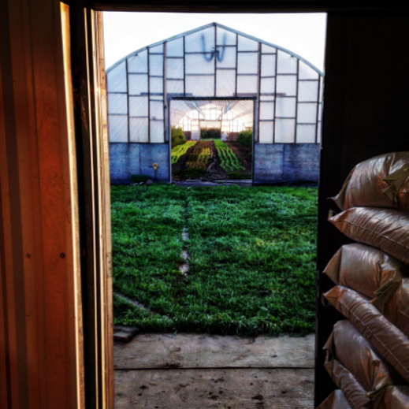

Chapter 4 – Sustainable Transportation

Active and sustainable transportation enhances physical, mental, and emotional health, and provides economic and environmental benefits. A sustainable transportation system means building a city where people have the option to walk, cycle, or use public transit as the preferred means of moving from place to place. It also means addressing the social and institutional barriers that prevent people from choosing sustainable modes of transportation.
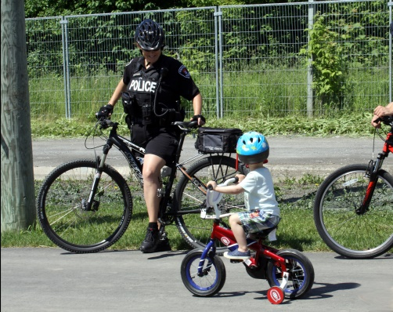

Did You Know?

DYK? The City's 2017 budget for Transportation & Infrastructure Services was $12,749,399.
Source: The City of Kingston
DYK? In 2017, Loblaws purchased the 1st fully electric transport truck on Canadian roads? The company intends to electrify its entire fleet to help reduce its carbon emissions by 30% below a 2005 baseline.
Source: Loblaws Media
DYK? Cycle Kingston facilitates 11 cycling clubs, hosts bike maintenance workshops, manages their social enterprise Gear Up, and advocates for a more bike-friendly community.
Source: cyclekingston.ca

Kingston Transit ‘APP’tly Getting More People On Board
More people are taking the bus than ever before. Kingston Transit is enjoying a banner year for ridership, surpassing last years’ ridership after enjoying year over year growth for the last 5 years. Jeremy DaCosta, General Manager at Kingston Transit, happily reported that September 2017 was the busiest month ever for Kingston’s bus service, with over 20% more trips than September 2016. Increased ridership is good news for City Council, who declared an aspirational goal of increasing mode of travel share of transit to 15% by 2034 (a big increase from the 2015 goal of 9%).
As a way to increase ridership and to help make Kingston a smart city, Kingston Transit provided standardized data into the public domain in June 2017. That release of data supplied real-time information about Kingston’s buses both to the public and to app creators. Integrated with other cities, and now available in Kingston, apps like Transit360, Google, MoveIt and CityTransit make it easier than ever to catch the bus. Bus riders can download apps for free on any computer, tablet or smartphone to get information on when their bus is arriving, in real time, or what buses are available near them. As Jeremy DaCosta explained, by sharing this data, Kingston is now part of the app community with no financial commitments. There are limitless possibilities for app development and, so far, Kingston Transit clients have benefited from integration of apps with multi-modal options like Uber, and crowd sourced customer ratings, along with real-time information about their bus location. Expressing yourself has never been easier, whether it be on an app or riding through town.
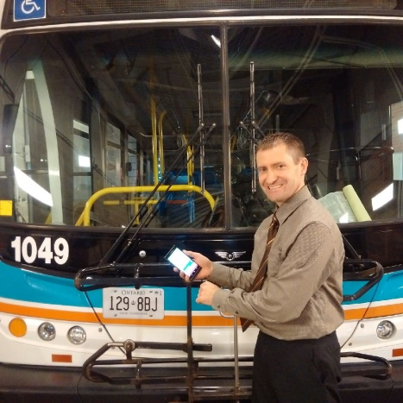

Ridesharing Made Easy
Pop Rideshare is a Vancouver-based start-up seeking to connect drivers and passengers across Canada through their mobile ride-sharing app. The service quickly evolved from its hitchhiking roots into a ride-sharing platform that now serves Toronto, Ottawa, Montreal, and, as of recently, Kingston. To date, Kingston’s performance is above the Pop average with 3.24 passengers including the driver per trip. According to the Canadian Vehicle Survey, Ontario’s average occupancy rate per light vehicle trip is 1.6 people.
Pop Rideshare’s business model follows the principles of the shared economy, a socio-economic system built around the sharing of human, physical, and intellectual resources. With over 3.5 million kilometers shared, Pop Rideshare helps build relationships while taking single-passenger vehicles off the road. Pop offers the advantages of flexible departure times, and supports routes to smaller communities that are underserved by buses and trains. As long as someone is driving, there is an opportunity to share a ride, make a friend, and reduce your carbon footprint in the process.
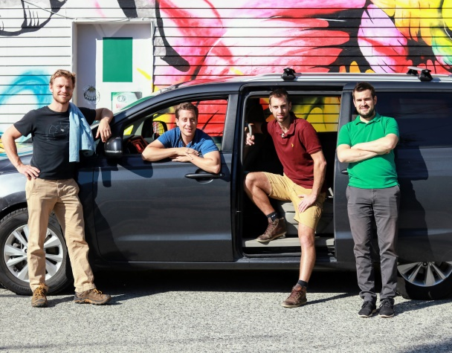

Commuter Challenge
Kingston comes out on top, again! Kingston once again achieved first place in the national Commuter Challenge for cities of similar size. During the weeklong challenge, (June 4 – 10) Kingston residents collectively travelled 48,951 kilometers, avoided 8,156 kilograms of carbon dioxide, saved 3,340 litres of fuel and burned 530,577 calories by using active and sustainable modes of transportation instead of using their vehicles. Kingston also placed first in Canada among cities of its size and had the highest number of participants in Ontario, ahead of larger cities like Toronto and Ottawa. With 572 registrations, Kingston also had the fifth highest number of participants in the country.

Dropbike: The Orange Revolution
At the start of summer 2017, the City of Kingston welcomed Dropbike Inc., the community’s first bike-sharing pilot program. The vibrant orange bikes can be rented for only $1 per hour without membership and, during the pilot, were easy to spot around Kingston’s downtown and Queen’s University Campus. The pilot allowed riders to find a Dropbike through their smartphones, unlock, and park them at any of the designated “haven” parking areas. Local businesses have also opened up to Dropbike allowing havens to be placed nearby to increase pedestrian traffic and support a cycle-friendly city.
As Dropbike launched on Canada Day with 100 bikes and 12 havens, the pilot program grew quickly and doubled the amount of bikes, which led to more than 6,000 trips by November 2017. The pilot has proven to be effective for micro transit, accessible to low income residents and attractive to students, tourists and locals alike.
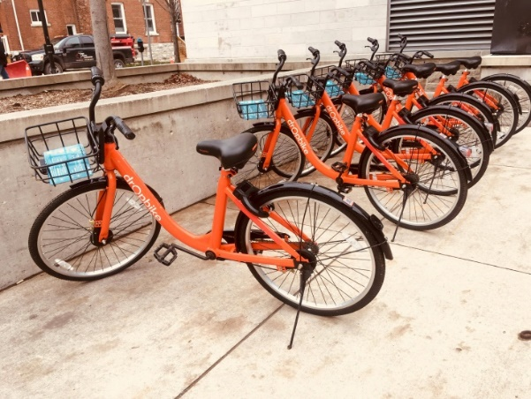

K&P Trail
The City of Kingston celebrated the opening of the newly completed section of the K&P trail during the summer of 2017. The trail dating back to the 1800’s, served as a railway track for steam engines. Since then, the K&P has become a place of scenic experiences and recreational uses.
The paved urban portion, covering 7 km, has been successful in adding to the use of the existing trails. Neal Unsworth, Manager of Parks Development, Recreation and Leisure Services, notes that trail usage has been significantly higher than expected with many users going on recreational trips as well as connecting urban dwellers to the rural and suburban areas.
Winding through Douglas Fluhrer Park and Kingston's Inner Harbour as well as the Old Industrial area, the K&P trail has been a positive incentive for citizens to embrace an active life style and promote sustainable transportation within the community.
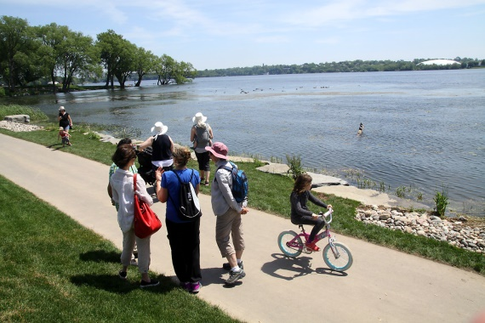

Electric Vehicle Charging Stations
In October, City Council approved plans to install a network of electric vehicle (EV) charging stations across Kingston. The aim is to reduce greenhouse gas emissions by encouraging the electric vehicle market in Kingston. Some of the plans include replacing petroleum engine vehicles in the municipal fleet with electric vehicles, installing various electric vehicle charging stations of different capacities, and readying the local electrical distribution network for EV charging demand.
Two 120 volt (Level 1), twenty-five standard 220 volt (Level 2), and two 450 volt fast DC charging stations (Level 3) will be installed and operated at municipal parking lots, recreational facilities and other city service locations such as Belle Park, Lake Ontario Park, the Memorial Centre and INVISTA Centre. The network will include Level 1 and 2 charging stations at no cost to the general public for their first two years of operation, while level 3 stations are estimated to cost users about $10-$15 per hour upon their launch.
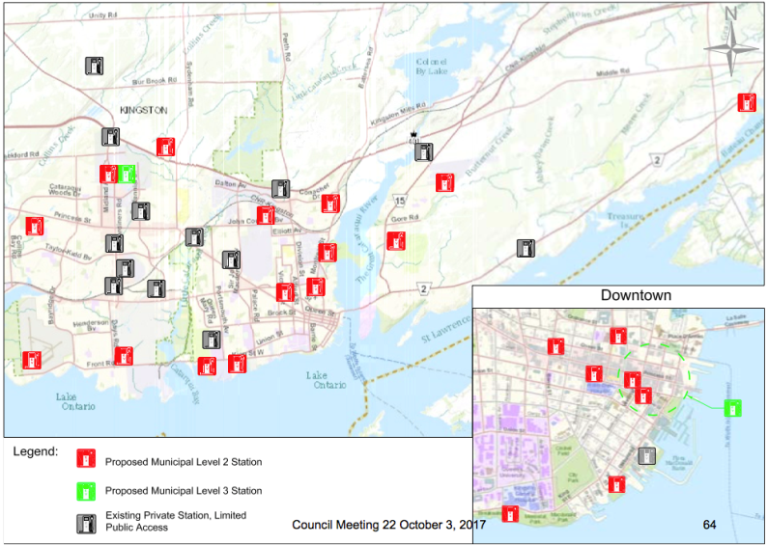

Chapter 5 – Sense of Community

Sense of community refers to people’s perception of interconnection and interdependence, shared responsibility and common goals. This Priority Area considers actions that improve civic engagement, lower barriers to inclusion, and make Kingston a welcoming and supportive community. Having a strong sense of community is important because it helps build social capital among residents and encourages volunteerism and citizen involvement. Also, a community that is rich in social capital provides a wealth of intelligence, sensitivity, and wisdom that will underpin and support community sustainability efforts.
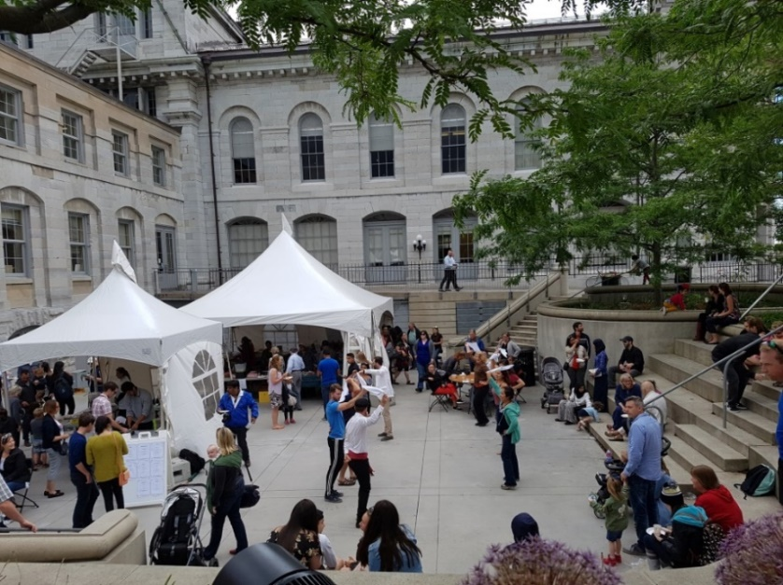

Did You Know?

DYK? Individuals who participate in at least one arts, culture or heritage activity are nearly three times more likely to report a very strong sense of belonging to each other and to their communities.
Source: Community Foundations of Canada, 2017
DYK? 85% of Canadians agree that participation in sport builds stronger communities by bringing people together, building social capital and fostering greater inclusion.
Source: Community Foundations of Canada, 2017
DYK? Over 60% of those 65+ stated that their sense of belonging was “somewhat strong.”
Source: Community Foundation for Kingston and Area – Vital Signs Report, 2017

Broadmind: Strategies For Mental Health
Broadmind is a social enterprise established in 2017 that provides courses, workplace presentations and strategies to improve mental health. Sherry Lachine, the owner, realizes the importance of mental health within the community and firmly believes that sustainability starts by fostering respect, tolerance, empathy and a strong sense of community.
Broadmind’s unique and non-conventional approach to mental health literacy allows individuals to realize the benefits of maintaining mental health through self-care and social support, having completing 24 Mental Health First Aid courses. In the long run, Sherry aims to transform Kingston into the community with the most mental health trained people in Canada. She hopes that other like-minded people and mental health professionals will join her mission and share her passion to make Kingston a better place to work and play.
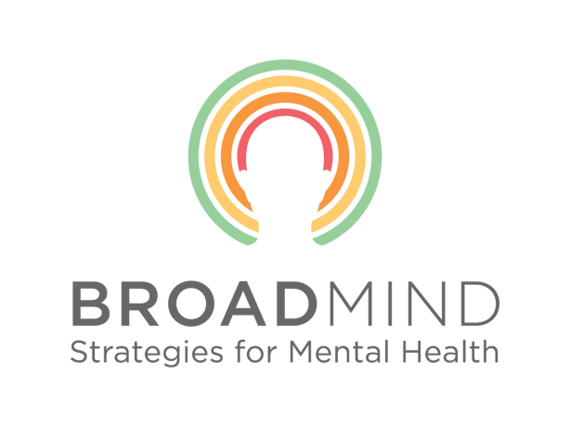

Nightlight
Nightlight, an adult drop-in centre, offers a safe place to hang out, chat and play games – including Jenga and Farkle – to anyone that walks through their door. Their goal is to promote a sense of belonging through companionship and the encouragement of individual friendships among those who feel lonely, excluded or marginalized. By providing a space for people to be accepted, encouraged and celebrated, Nightlight assists with overcoming exclusion and promoting positive attitudes and behavior among its users. Nightlight has been contributing to Kingston’s social sustainability for almost 6 years, creating meaningful relationships and a sense of belonging that all starts over a cup of coffee.
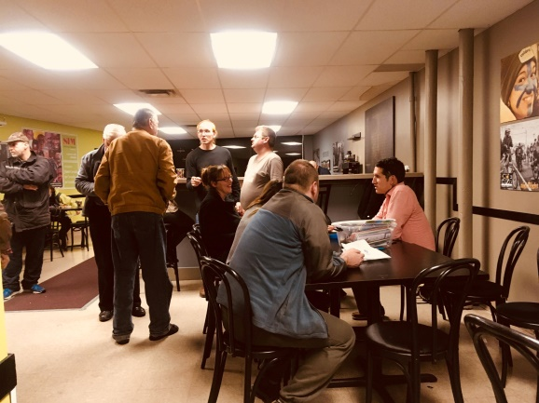

Community Inclusion Program
The Community Inclusion Program offered by Community Living is one of the oldest initiatives contributing to social sustainability in Kingston. The program focuses on helping seniors and individuals with a developmental disability with inclusion in the community.
The program offers volunteer opportunities, sports, recreation, education and additional supports for about 130 individuals across three local sites. What makes the program stand out? The services offered are individualized, designed according to the needs and goals of each participant. With the help of over 50 non-profit organizations, it offers off-site services to participants that enable their independence and participation in their communities. It also allows users to create their own experiences by working with other people in safe spaces where they are heard, understood, and kindly supported. As the Community Inclusion program continues to grow, Community Living hopes to incorporate social enterprises and employment opportunities in the near future.

Katarokwi Learning Centre
The Katarokwi Learning Centre is an alternative learning site that offers a mix of independent and group learning opportunities to students from grades 9 through 12, adult learners and Indigenous people. The purpose of the Katarowki Centre is to offer a range of quality educational programs in a safe, positive and caring environment for individuals who need support.
Kelly Maracle explains how the centre is actively trying to promote and strengthen the sense of community among students by engaging them in a new approach that allows for interaction and community building between peers through on-site activities. Students can enroll in programs such as art and woodshop, nutrition, power fit and hands-on learning, where they would not only learn but be able to interact and befriend their peers.
The Centre also offers the River program, which is Indigenous Based Education, intended to provide First Nation, Metis and Inuit students a safe, inclusive and culturally rich learning environment. The Katarowki Learning Centre is actively helping the community become more sustainable by creating a sense of community among its students, embracing diversity and focusing on respect for self, others, Indigenous traditions, and community.
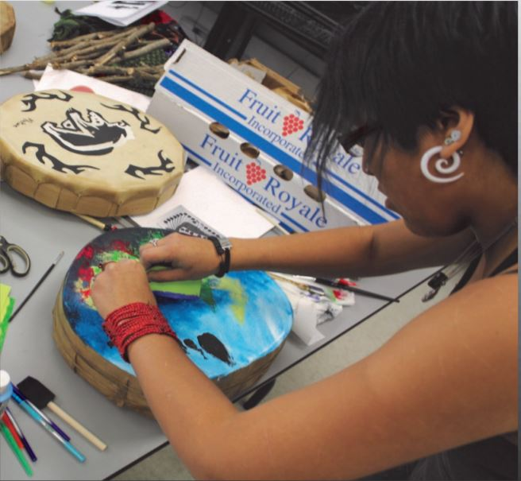

Co-Working Together
Traditional office space just does not cut it anymore with the rise of start-ups, entrepreneurs, remote workers, and social enterprises. With the need to reduce overhead costs of renting and the desire to work and play in an urban, densified area – finding a place to work can be tricky. Co-working spaces are membership-based workplaces that actively encourage collaboration and curate meaningful spaces for their members. Over the last year, Kingston has welcomed two very different but equally important co-working spaces to the community: The Spire and The Sanctuary.

Co-Working Space 1 – The Spire
The Spire of Sydenham Street United Church focuses its membership on those groups, charities and non-profit organizations that provide a community service, being a popular venue for cultural events and plays an important role in social justice, spirituality and the arts. In an average week, this heritage building opens its doors to hundreds of community members and continues to be the home of the Cantabile Choirs of Kingston and the Kingston Canadian Film Festival.
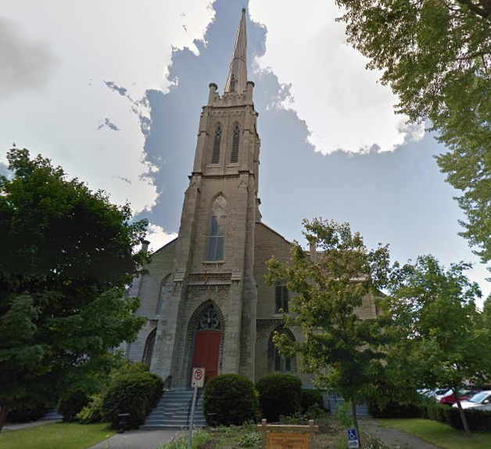

Co-Working Space 2 – The Sanctuary
The Sanctuary provides small and affordable office space to new and small businesses in the Kingston community. They aspire to be a leader in community growth and a hub for responsible entrepreneurialism. Their professional outlook includes all-inclusive amenities and promotes many social activities that are found in the downtown area.
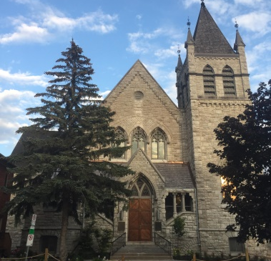

Chapter 6 – Environmental Stewardship

The idea of stewardship stems from responsibility to remain accountable for the consequences of one’s actions. In understanding the interconnectedness of our ecology, we know that our human activities have direct consequences on the physical environment. Environmental stewardship calls upon the community to share the responsibility of protecting and sustaining our shared environment.
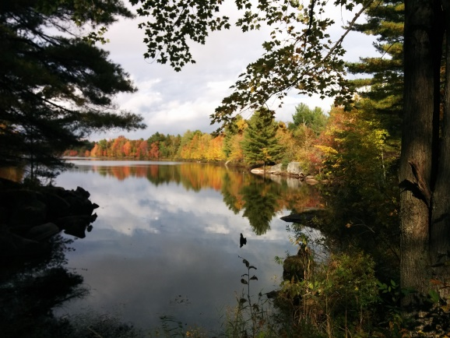

Did You Know?

DYK? The City of Kingston has a network of Environmentally Protected Areas. These are environmentally sensitive lands that should be maintained in their natural, undisturbed state.
Source: City of Kingston
DYK? Kingston has a household waste diversion goal of 65%. Help us recycle, compost and eliminate waste all together.
Source: City of Kingston
DYK? The Government of Ontario lists 30 at risk species in the Frontenac area, 9 of which are listed as endangered.
Source: Ministry of Natural Resources and Forestry

The Buzz On Campus
Pollinators, like bees, are an important part of our food supply. One-third of human food is dependent on pollinators. But, bees aren’t as busy as they once were in Ontario. Bee populations have declined 50 percent since the 1940’s, and two species of bees are listed as ‘endangered’. A startlingly high number given that this is mainly due to human interaction and habitat destruction. This is one reason why the Society for Conservation Biology developed a garden outside the Bioscience complex at Queen’s University.
Swarming together for a ribbon cutting ceremony on September 21, the Society for Conservation Biology, students, community members, bee keepers, and even an observation hive celebrated the opening of the garden and discussed the important role of bees. This idea bloomed in September 2016, and the Society started advocating the importance of maintaining pollinator populations. Significant consideration went into the garden, including habitat and species research, to make the garden features attractive to pollinator bees. A carefully selected mix of mainly native species plants ensure early, mid-summer, and autumn blooming. After a full school year of being worker bees, the Society’s garden is now officially open for pollination and it is as sweet as honey.
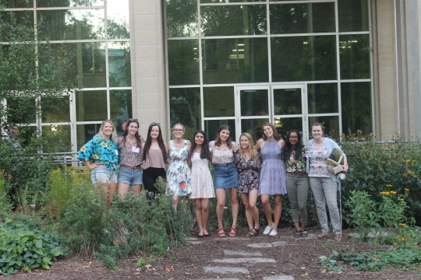

Trash TurnAround
The Skeleton Park Arts Festival (SPAF) held its annual three-day arts festival at McBurney Park, a.k.a. Skeleton Park, in June. While the festival attracts thousands of people over the weekend, this local, non-profit organization has worked hard to strive for not only a successful community event, but one that is zero waste. In 2017, the SPAF partnered with Sustainable Kingston to develop a Waste Diversion Manual that highlights techniques to reduce waste at the vendor and participant level, reuse materials such as marketing signs and recycle the remaining.
To manage the waste that cannot be eliminated, the SPAF established a waste diversion committee and featured a waste sorting station at the event. Garbage bins around the park were removed for the duration of the weekend and volunteers manned the sorting station to help participants properly dispose of their food or packaged waste. Only one bag of garbage was collected over the entirety of the event, consisting of mainly straws, small utensils and pet waste. Great job SPAF!
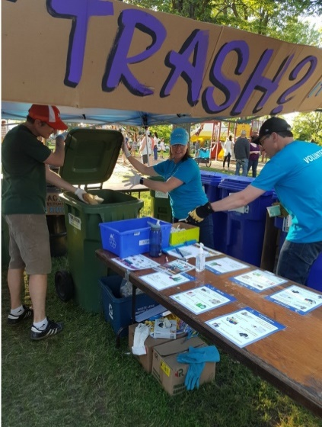

Tracking the Turtles of Inner Harbour
Last year, the Friends of Kingston Inner Harbour was featured for their turtle awareness and protection project. By tracking and mapping the turtles, many exciting discoveries about species specific behaviours, challenges and biology were made. Through continued tracking in 2017, it was discovered that there are more turtles then expected in the Inner Harbour Area. The population, including snapping, painted and northern map turtles, is also much more mobile than predicted. One snapping turtle nest found almost a kilometer inland! The project has also protected over 100 nests again this year.
Alongside the addition of basking logs along the newly developed K&P trail, hosting “Turtle Awareness” weekends with Reptile and Amphibian Advocacy and local Indigenous Knowledge Holders, as well as a partnership with Dr. Steve Lougheed’s research group at Queen’s University, the Friends of Kingston Inner Harbour know their project has definitely been a success and hope it will continue to grow!
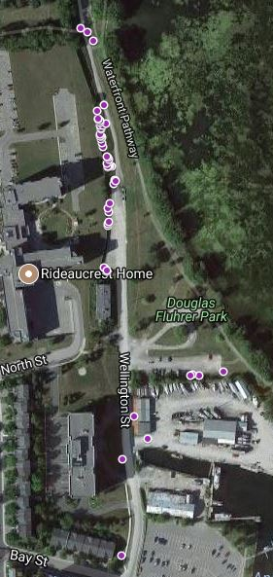

Shop Responsibly – Live Sustainably
Located in the John Deutsch University Centre on Queen’s campus, The Earth Centre is an organization that aims to help their community reduce their consumerism footprint on the environment. They provide access to inexpensive and environmentally-friendly products by purchasing products at wholesale and selling them at-cost to help make green consumer choices available on a budget. It’s also open to all members of the public and not exclusive to students.
The Earth Centre’s Drop-Off program helps reduce end-of-product impacts where they accept items such as batteries, ink cartridges and light bulbs and swap their inefficient bulbs for new efficient bulbs at no cost. Partnering with the City of Kingston, they also offer free compost and recycling bins to encourage eco-conscious choices for consumers through every step of product life.
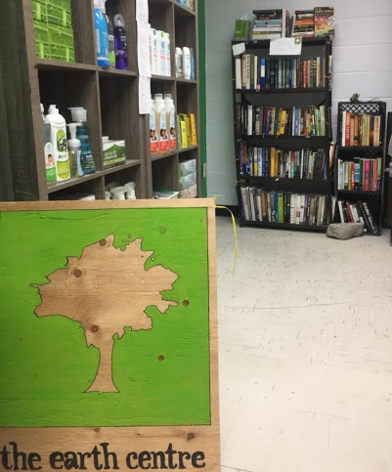

The Water of Cataraqui Region
With over 170 bodies of water in the Cataraqui Region, the Cataraqui Region Conservation Authority (CRCA) works to conserve the strength of our water systems. Through monitoring and sampling, the CRCA is able to determine the health of some of our most important waterbodies, to help make predictions and sometimes place restrictions.
In 2017, the CRCA published the Cataraqui Region Lake Assessment Report along with 45 individual Lake Fact Sheets. This report will be updated every 5 years to include regional data trends, highlight potential issues and review the health of lakes within the Cataraqui Region. Whether it be for aquatic life, drinking water or recreation, conserving the health and resiliency of our water is important for all of us.
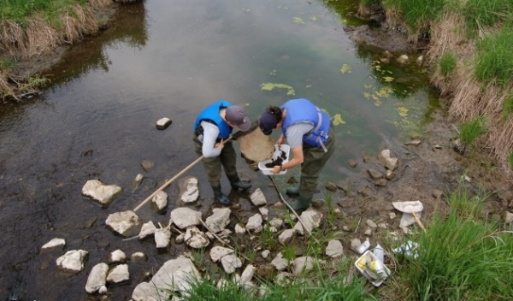

Kingston Pitched-In, Again!
Every year, Sustainable Kingston hosts Pitch-In Kingston, a community event designed to celebrate Earth Day by cleaning up waste around our neighborhoods. Local workplaces, sports teams, community groups, schools, and individuals participate, with the bright yellow collection bags were available for pick up from Sustainable Kingston, the Kingston & Area Real Estate Association and Tim Horton’s locations across the town. In 2017, the week-long Pitch-In Kingston event saw a 66% increase in waste collection, with 112 teams and 2975 participants registered. Over 830 bags of waste were collected. Way to go, Kingston!
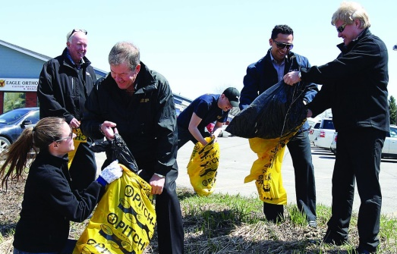

Acknowledgements
A team of Sustainable Kingston volunteers were responsible for interviewing the many organizations featured in this report.
Samantha Duff
As the acting Environmental Stewardship Ambassador for Sustainable Kingston, it was a pleasure to get to learn about the different projects being taken on by only a few of Kingston’s great environmental protection groups! There are so many concerned individuals and organization who are working to conserve all the beauties and creatures of this area. Currently completing a Collaborative Master’s in Applied Sustainability at Queen’s University, I have a heavy interest in renewable energy and a clean future. Being new to the Kingston area in 2016, I got onboard with Sustainable Kingston to learn more about what sustainability meant to this community and be a part of protecting our lands and our future.
Danais Ponce
Danais moved to Kingston in 2016 to pursue a master in Urban and Regional Planning at Queens University. She loves to volunteer and enjoys being an active participant within her community. Participating in Kingston Community Sustainability Report not only allowed her to remain engaged but also gave her the opportunity to explore issues of sustainability. She is passionate about communities and social issues as cities need to be inclusive and designed to meet the needs of those who live in them. Through the Community Sustainability Report, she was able to learn about many initiatives and programs that are happening in Kingston and met incredible and inspiring individuals. Danais hopes the report will make Kingstonians proud and aware of the many sustainable initiatives the city of Kingston has.
JoAnn Peachey
JoAnn is currently a Master’s student at Queen’s University in the School of Urban and Regional Planning. Seeing a strong connection between urban planning and sustainability efforts, she joined Sustainable Kingston this February to volunteer as a Climate Action Priority Area Ambassador. She was inspired by the community members she had the opportunity to interview for this report and see firsthand how Kingston is embracing innovative ideas and news ways of life.
Szeréna Szabó
Szeréna is an environmental blogger, artist as well as a volunteer for Sustainable Kingston. Between pursuing her Bachelor’s in Environmental Science at Queen’s University, she finds passion in sharing her knowledge on environmental issues and connecting with people through her artwork.

About Sustainable Kingston
Our mission is to enhance the livability and resiliency of Kingston by sharing knowledge and providing resources and programs that drive community action.
We are a small, dedicated team motivated by a shared passion for progress towards sustainability in Kingston. We work together with our volunteers and community partners to realize our community’s vision for sustainability: Kingston, Canada’s Most Sustainable City.

2016 - 2020 Priorities
Until 2020, Sustainable Kingston will be focusing on sharing stories and measuring community progress around six priorities for action in our community – Climate Action, Sustainable Transportation, Economic Prosperity, Food Security, Sense of Community, and Environmental Stewardship.

Share Your Organization's Story
The stories featured in this report were selected by Sustainable Kingston staff and volunteers from a much longer list of organizations, businesses and programs that are making a difference in our community.
Is your organization working on a change-making project in the sustainability space that you want to share with the community? Please contact us so we can help share your story!

Contact us:
Telephone: (613) 544 2075
Address: 201 – 303 Bagot Street, Kingston ON, K7K 5W7
Email: info@sustainablekingston.ca
Website: www.sustainablekingston.ca

